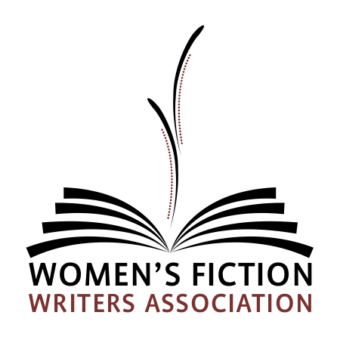

For Immediate Release

Women’s Fiction Writers Association Announces Finalist for the 2020 RISING STAR Award for Unpublished Women’s Fiction

June 22, 2020: The Women’s Fiction Association (WFWA) is excited to announce the 2020 finalists for the RISING STAR Award for an unpublished Women’s Fiction novel by an unagented author.

The annual contest is open to anyone with a complete Women’s Fiction novel. The first round is judged by published authors and allied industry professionals. The five top-scoring entries are judged by literary agents who acquire Women’s Fiction. The winner will be announced in September.
Women's Fiction is a writing genre that includes layered stories in which the plot is driven by the main character’s emotional journey. The stories can be contemporary or historical, and may have magical, mystery, thriller, romance, or other elements.
If you are an editor or literary agent and interested in any of these manuscripts, please email the RISING STAR Award chair, at risingstar@womensfictionwriters.org.

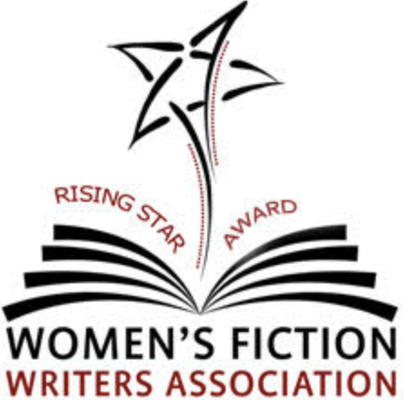

In alphabetical order:

Kilby Blades - Crocodile Tears
After a ten-year absence, Ruby returns to her hometown to attend the funeral of Dale Flynn, the late patriarch of a family who has feuded with her family for generations. Outing their friendship is the least of her worries. When Dale wills half his fortune to Ruby, it enrages Dale’s estranged son and heir apparent, Wes. And, in order for either to collect, they must work together to end the feud.

Melissa Lanning - Crooked Lake
A broken-hearted woman must return to her family’s struggling vineyard in the Finger Lakes of New York state after her self-imposed exile because of her guilt over her baby sister’s death. If she can uncover the truth about the 1926 disappearance of a flapper girl, she could save her family’s wine business and finally forgive herself.

Barbara Ristine - Faces of War
FACES OF WAR explores how WWI artists and doctors collaborated to restore hope to facially disfigured soldiers. When Meg Bradshaw fails to get into art school, she gives up her art. After her brother is reported MIA, she volunteers in a military hospital, and she discovers a new purpose for her art in the Tin Noses Shop where artists create life-like masks to help men re-enter civilian life.

Brigette Russell - Practically Perfect In Every Way
Dora is a control freak and a single mother whose life is thrown into chaos when her teenage son tracks down his sperm donor father. Bad enough Dora has a co-parent—worse that she’s attracted to him. Struggling to get her life back just the way it was, Dora learns that practically perfect can be the enemy of the very, very good.

Rebecca J. Sanford - Scarves
A 28-year old woman who was adopted at birth is approached by a stranger from Argentina believing to be her biological brother. When she pursues her natural identity by taking a DNA test, she uncovers a secret that her adoptive father — a U.S. military officer stationed in Buenos Aires during the Dirty War — has been keeping from her all her life.

CONGRATULATIONS to all!
About The Women’s Fiction Writers Association (WFWA)
The Women's Fiction Writers Association (WFWA) was founded in 2013 as a professional, non-profit organization for women’s fiction writers and publishing professionals. With more than twelve-hundred international members and growing, WFWA is the premier organization for Women's Fiction. WFWA fosters an online community of inclusion and opportunity, and provides resources, professional development, networking, and support for aspiring, debut, and published women’s fiction authors. Learn more at www.womensfictionwriters.org. Twitter: @WF_Writers Instagram: womensfictionwriters.

